Maine Shared Community Health
Needs Assessment

Stakeholder Forum Planning Guide

2024

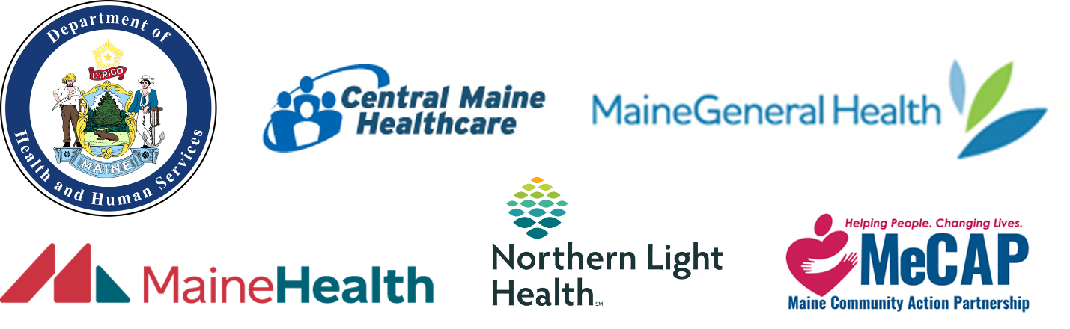

Table of Contents
Overview 4
MESCHNA Overview 4
Governance Structure 5
MeSCHNA Process 6
MeSCHNA Timeline 8
Stakeholder Forums 8
Overview 8
Forum Agenda & Speakers 9
Meeting Materials 10
Participants and Registration 10
Forum Guidance – In-Person Events 12
Space Requirement Check List 12
Individual Roles Check List 13
Forum Guidance – Virtual Events 14
Space Requirement Check List 14
Individual Roles Check List 14
Post-Event 15
Appendix A 16

Overview

This document serves to provide an overview of the Maine Shared Community Health Needs Assessment process and to provide guidance on planning and hosting the Stakeholder Forums for both in-person and virtual formats.

MESCHNA Overview

The Maine Shared Community Health Needs Assessment (MeSCHNA) is a collaborative between Central Maine Healthcare, MaineGeneral Health, MaineHealth, Northern Light Health, Maine Center for Disease Control and Prevention (MeCDC), and the Maine Community Action Partnership (MeCAP). Every three years, the MeSCHNA coordinates a statewide community health assessment. By doing this together, duplication is avoided while fostering collaborative partnerships. The MeSCHNA’s vision is to turn data into action so Maine will become the healthiest state in the U.S. The mission is to create shared community health needs assessment reports; engage and activate communities; and support data driven health improvements for people in Maine.
In addition to its mission and vision, the health needs assessment fulfills federal ACA/IRS reporting requirements for health systems, Community Services Block Grant (CSBG) reporting requirements for the Community Action Programs (CAPs), and public health accreditation requirements for the MeCDC through the Public Health Accreditation Board (PHAB). Below is a list of common requirements that inform the MeSCHNA:
Timing | At least every 3 years. This is the 5th triennial effort (2010, 2015-2016, 2018-2019, 2021-2022, and now 2024-2025).
Collaboration | - For PHAB and CSBG: collaboration required  - For ACA/IRS: collaboration highly encouraged
Service Area | This combined effort involves the entire state. This includes hospital service areas, Public Health Districts, and the Community Action Partnership network.
Partners | Must include input from:  - Public Health professionals  - Government  - Public Health department staff  - Medically underserved or organizations who serve them  - Low income population and organizations who serve them  - Minority populations or organizations who serve them  - Faith based organizations  - Educational institutions  - Community based organizations  - Private sector  - Public sector
Requirements | - Assess and prioritize top health issues  - Compile potential community resources to address health priorities  - Lists gaps and or barriers to overcoming identified health priorities  - Describe the local challenges in the social determinants of health  - Describe the health surveillance system (PHAB)  - Include description and examples of how data is being used (PHAB)  - Collect comments of previously adopted health improvement plans
Process | The assessment process and criteria used to identify health needs must be outlined.
Documentation | - Meeting minutes, emails, website or other documentation used to collect data and information  - Description of criteria used to identify health priorities and resources  - Description of which model or framework was used  - List of organizations representing board interest of the community who were consulted during the engagement process
Data | - Describe process of identifying data sources, methodology and analysis  - Must include ‘context for the population’ such as census, employment, income, education, voter registration, transportation, parks, housing stock, home values, etc.  - Must include primary data collection through either surveys, focus groups, interviews, or talking circles, for example  - Must include agency data and customer satisfaction data (CSBG)
Final Product | - For ACA/IRS: written report adopted by a hospital board  - For PHAB: Description of how results are to be shared and used; ongoing monitoring and updating of data  - For CSBG: written report approved by the Board of Directors
Follow-up | - Hospitals use final reports to develop Community Health Improvement Plans  - The State of Maine and other health departments use final reports to develop the State Health Improvement Plan.  - Community Action Partnerships use the final report to develop their strategic plans.

Governance Structure

The Maine Shared Community Health Needs Assessment is overseen by a Steering Committee comprised of one representative from each of the signatory partners. They provide guidance, oversight, and ultimate approval of the project. A Program Manager reports to the Steering Committee and oversees the work of the Metrics Committee, Community Engagement Committee, and any ad hoc committees.
The Metrics Committee:
- Creates a common set of population/community health indicators;
- Produces a preliminary data analysis plan;
- Identifies processes for regularly reviewing indicators to stay abreast of research; and
- Makes recommendations for annual data-related activities and projected costs associated with recommendations.

The Community Engagement Committee:
- Develops a framework for an equitable, inclusive and robust community engagement;
- Provides recommendations for geographic and demographic communities with which to engage; and
- Builds relationships with communities identified for engagement.

MeSCHNA Process

The MeSCHNA process consists of four major elements:
- Data analysis
  - Data health profiles will be completed for each County, 3 urban areas (Portland, Lewiston/Auburn, Bangor), and the State.
  - Health equity profiles will also be completed on topics such as: race, ethnicity, sexual orientation, sex, education, income, age, insurance status, rurality, etc.
  - All data profiles will be made available to Forum registrants prior to the Forums for their review and consideration.
- Community engagement
  - 6 statewide focus groups will be held with populations who are historically underrepresented, have disparate health outcomes, and/or are adversely impacted by social drivers of health.
  - At least one focus group will be held in each County for people with low-income.
  - Up to 30 key informant interviews will be conducted with professionals and/or advocates representing populations who are historically underrepresented, have disparate health outcomes, and/or are adversely impacted by social drivers of health and/or sectors that are related to health outcomes.
  - A statewide survey.
- Stakeholder Forums
  - Each County will host one Stakeholder Forum (with the exception of Cumberland, which will host two) between September and November 2024. The Forums are organized by Local Planning Teams.
  - Using information from both the data analysis and community engagement process, Forum participants will engage in a health prioritization process, ultimately making recommendations to the Steering Committee.
- Community Health Needs Assessment reports
  - The Steering Committee will review the health prioritization for each County and the State, finalizing those to be included in final reports.
  - Each County and the State will have a report with relevant data, community engagement findings, and health priorities for taking action.
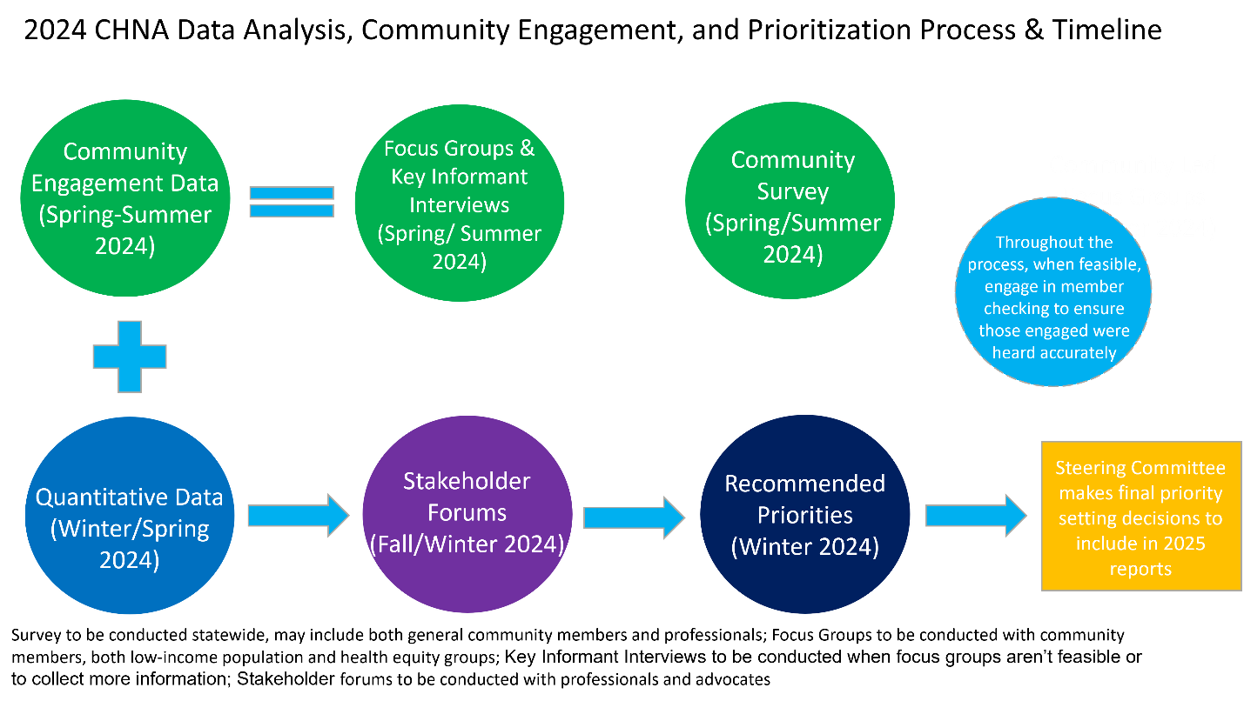

MeSCHNA Timeline

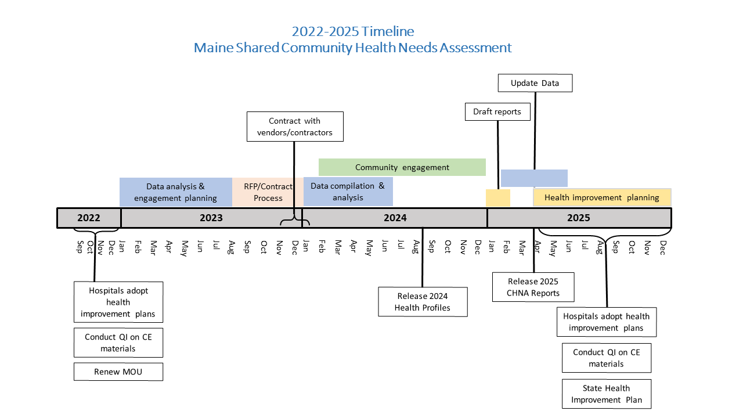

Stakeholder Forums

Overview

The purpose of the Stakeholder Forums are to bring professionals and advocates together to review qualitative and quantitative data and ultimately make recommendations on health priorities for each County and the State.
There will be one Forum per County with the exception of Cumberland County which hosts two. Each Forum will last approximately three hours, with 30-60 minutes before and after for preparation and breakdown.
The following are the roles of the Local Planning Teams. Additional information on those roles and the roles of Crescendo are provided below. Appendix A also includes a timeline and roles and responsibilities of the Local Planning Team.
Local Planning Team Role Overview:
- Identify someone to conduct the Forum welcoming remarks (talking points can be provided)
- Identify a facilitator and flip chart writer for each in-person Forum. Identify a facilitator and chat monitor for each Virtual Forum breakout.
- Review and provide feedback on the Forum “Overview of Key Findings” presentation.
- Crescendo will provide 12 black and white copies of each of the following: data profile, community engagement overview, and overview presentation and a sign-in sheet. Materials desired beyond this will be printed by the Local Planning Team.
- Identify Forum invitees.
- Email Forum invitations and event reminders.
- Identify a location for the Forum, if in-person.
- Set-up and breakdown of the space, if in-person.
- Send a follow-up email to Forum participants.
- Review draft County reports.
This Planning Guide makes some reference to Cohorts. If your Forum is happening in:
- September, you are Cohort 1;
- October, you are Cohort 2; and
- November, you are Cohort 3.

Forum Agenda & Speakers

Both in-person and virtual events will follow the same agenda. A draft agenda is provided below. Note that new this cycle, the Forum will not include leadership remarks or updates on progress from previous cycles. Updates on progress from the previous cycle will be provided via documentation made available on-line and during presentations at the summer and fall District Public Health meetings.
A run of show template will be provided once the agenda and technology to be used are finalized.
- Welcome (5 minutes)
- Overview of Key Findings and Preliminary Voting Results (30 minutes)
- Breakout #1 (25 minutes)
- BREAK (10 minutes)
- Breakout Reports and Second Round of Priority Voting (15 minutes)
- BREAK (5 minutes)
- Presentation of Final Priorities (10 minutes)
- Breakout #2, Round 1 (25 minutes)
- Breakout #3, Round 2 (15 minutes)
- Breakout #4, Round 3 (15 minutes)
- Next Steps (5 minutes)
The Local Planning Team is asked to identify someone to do the welcoming remarks. Talking points can be provided if desired. Crescendo and/or the MeSCHNA Program Manager will lead the overview of findings and discussion and next steps. Local Planning Teams will identify facilitators, flip chart writers (in-person), and chat monitors (virtual) for the breakouts. Recruitment for these roles should take place in June, July, and August for Forum Cohorts 1, 2, and 3 respectively. Crescendo will provide training for the facilitators, flip chart writers, and chat monitors and provide any materials they will need to conduct their role. Trainings will take place virtually from 9am-10am on the following dates. All trainings will be recorded, but attendance is highly encouraged:
- Cohort 1 – September 6th
- Cohort 2 – September 27th
- Cohort 3 – October 25th
Facilitator, Flip Chart Writer, and Chat Monitor Role Descriptions:
- A facilitator leads the discussion.
- A flip chart writer captures the discussion on flip chart paper for in-person Forums.
- A chat monitor shares relevant comments from the chat and documents them in a shared virtual space (ex: IdeazBoard, Google document, etc.) for virtual Forums.

Meeting Materials

Crescendo will take the lead on developing all meeting materials, including sign-in sheets and will organize the use of any technology for voting, note taking, discussion, etc. Crescendo and the MeSCHNA Program Manager will also develop PowerPoint presentations to be used during the Forum. The Local Planning Team will be asked to review the “Overview of Key Findings” presentation prior to the Forums to ensure relevance to the County within which the Forum is held.
Crescendo will provide each in-person Forum with 12 copies of each of the following: data profile, community engagement overview and overview presentation and a sign-in sheet. If Local Planning Teams would like additional copies or materials, they will be responsible for printing. The MeSCHNA Program Manager email electronic materials packets for both in-person and virtual Forums to registrants.
Printed materials include:
- Overview of Key Findings and Preliminary Voting Results presentation
- Data profiles
- Community engagement overviews
- Sign-in sheet
Registrants will be directed to the MeSCHNA website to access:
- Data profiles
- Community engagement overviews
- Progress update reports and presentations
Registrants will receive notice of their breakout room assignment with their confirmation email.

Participants and Registration

The Maine Shared Community Health Needs Assessment aims to have an equal representation of public health, health care, social services, and related topics and sectors in attendance at the Stakeholder Forums, as well as, an equal representation of organizations from within the County where the forum is held. To that end, invitations will be sent to individuals and organizations, as opposed to, a blanket outreach for attendance. Local Planning Teams are encouraged to think strategically to make sure the right people are in the room and there aren’t any biases toward one sector, organization or topic. For example, a Local Planning Team would want to invite 1-2 people from an organization with overall knowledge of its work, rather than 10 individuals. An ideal range of participants is 25-40 people, acknowledging this may vary from County to County. Local Planning Teams are asked to identify individuals to invite to the Stakeholder Forums.
Per reporting requirements certain sections must be included. The first list indicates those sectors that must be included. The second list provides suggestions of other sectors you may want to think about including. Some of these sectors will have been consulted through other community engagement efforts, (focus groups, key informant interviews, and a survey); however, Local Planning Teams should make an effort to include these sectors as the Forums are one piece of the collective community engagement effort. The MeSCHNA Program Manager will invite the Maine Federal Congressional Delegation and MeCDC Director Va to attend a Forum(s) of their choosing, if available.
1. Sectors that Must be Included:
- Community-Based Organizations
- Faith-Based Organizations
- Private Sector
- Public Sector
- Educational Institutions (early childhood, K-12, higher education)
- Low-Income Serving Organizations
- Minority Serving Organizations
- Medically Underserved Serving Organizations
- Public Health
- Government (local, state)
- Public Health Department

2. Sectors that May be Included:
- Community Action Programs
- Health Care (including consumer advocates)
- Non-Profits
- Health Insurance and Managed Care Organizations
- Community Health Centers
- Labor and Workforce
- Substance Use
- Healthy Eating, Active Living
- Oral Health
- Mental/Behavioral Health
- Emergency Management Agencies
- Child Welfare
- Youth Serving Organizations
- Climate/Environment
- Organizations Serving the Disability Community
- Tribal Communities
- Immigrant Serving Organizations
- Refugees/Asylee Serving Organizations
- Migrant/Agricultural Worker Serving Organizations
- Older Adult Serving Organizations
- LGBTQ+ Serving Organizations
- Injury/Violence Prevention Organizations
- Transportation
- Housing and Development
- Public Safety
- Recreation
- Justice System/Juvenile Justice System (including incarcerated/formerly incarcerated)

Crescendo and the MeSCHNA Program Manager will also oversee registration and will provide the Local Planning Team with a list of confirmed participants prior to the Forum. The MeSCHNA Program Manager will provide updates on registration one month prior to the Forum and each week thereafter, including the day before the Forum.
The MeSCHNA Program Manager will provide a template invitation for Stakeholder Forum invitees and template reminder emails. These will be provided no later than June. A representative of the Local Planning Team will be tasked with emailing the invitations and reminder emails.

Forum Guidance – In-Person Events

Space Requirement Check List

The Local Planning Teams are charged with making sure the space for the Forum has the following capabilities and amenities:
- Common meeting space large enough for all attendees with chairs and tables
- Breakout rooms (highly preferred, but not required) to accommodate 5-10 people per breakout, including a facilitator and flip chart writer. Breakout rooms should also have chairs and tables. If breakout rooms are not available, the space should be big enough to move into small groups and limit competing noise.
- ADA compliant
- Table and chairs for welcome and signing in.
- Tables as needed for refreshments (if providing).
- Bathrooms
- A separate space for any lactation, prayer, etc. needs (highly preferred, but not mandatory)
- Podium or equivalent for presenting and hook up for computer.
- A projector/screen
- Microphone/speakers
- Free and/or validated parking

Individual Roles Check List

The following are roles the Local Planning Team is asked to take on for the day of the event:
- Set-up of the room (rounds tables, if possible, with 5-10 chairs at each)
- Set-up of a welcome table with a sign-in sheet and any necessary material packets (Crescendo will develop all of the materials and provide them with enough advance time for printing)
- Set-up of a table with refreshments, if providing
- 1-2 people to staff the welcome table
- 1 person to give the welcoming remarks (talking points can be provided upon request)
- 1 facilitator per breakout room to facilitate discussion and 1 flip chart writer to take notes capturing the discussion
  - *There may be multiple rotations through breakout rooms. The people may be the same for each session (ie: those who facilitate for the breakout #1 would also do so for #2 and #3)
  - **Crescendo will provide a training in advance of the Forums and provide any materials needed to conduct the role.
- 1-2 people to help set up flip charts in each breakout room. Crescendo will provide the flip charts.
- Break down of the room (per event space requirements)

Crescendo will take on the following roles:
- Collect and tabulate pre-Forum prioritization voting
- Prepare meeting materials (notetaking forms, attendance sheets, etc.)
- Provide training to facilitators and flip chart writers
- Provide and help with set-up of flip charts
- Presentation of “Overview of Key Findings & Preliminary Voting Results”
- Facilitation of 1-2 breakout rooms
- Presentation of the “Discussion and Next Steps”
- Tabulation of voting
- Receive and store any data gathered (notetaking forms, flip charts, voting records, attendance sheets)

Forum Guidance – Virtual Events

Space Requirement Check List

Virtual Forums will be conducted via Zoom. Crescendo will organize the Zoom space including the number of breakout rooms needed and any additional technology (ex: voting platforms, discussion boards, etc.) used.

Individual Roles Check List

The following are roles the Local Planning Team is asked to take on for the day of the event:
- 1 person to give the welcoming remarks (talking points can be provided upon request)
- 1 facilitator per breakout room to facilitate discussion and 1 flip chart writer to take notes capturing the discussion
  - *There may be multiple rotations through breakout rooms. The people may be the same for each session (ie: those who facilitate for the breakout #1 would also do so for #2 and #3)
  - **Crescendo will provide a training in advance of the Forums and provide any materials needed to conduct the role.
Crescendo will take on the following roles:
- Develop and administer any pre-forum surveys, if using
- Creation and administration of Zoom meeting rooms (creating log-in links, creating breakout rooms, sending people to breakout rooms, etc.)
- Prepare meeting materials (notetaking forms, attendance sheets, etc.)
- Oversee the registration process and provide registration lists to the Local Planning Team (done in collaboration with the MeSCHNA Program Manager)
- Provide training to facilitators and chat monitors
- Presentation of “Overview of Key Findings & Preliminary Voting Results”
- Facilitation of 1-2 breakout rooms
- Presentation of the “Discussion and Next Steps”
- Tabulation of voting
- Receive and store any data gathered (notetaking forms, flip charts, voting records, attendance sheets)

Post-Event

Local Planning Teams are asked to provide Crescendo with all notes, including flip charts and general notes and attendance sheets.
The MeSCHNA Program Manager will provide an email template to Local Planning Teams thanking participants for attending, a post-event evaluation, and information on next steps. A representative of the Local Planning Team will be tasked with sending this email. The template will be provided no later than one week after the Forum.
The Local Planning Team co-leads will also be asked to review draft County reports, specifically as they relate to the Stakeholder Forums. More information on the specifics of this, including timing, will be provided.

Appendix A

MeSCHNA 2024 Forum Planning Timeline & Responsibilities in Detail

If forums are held in: |  |  | Milestone | Local Planning Team | Crescendo | MeSCHNA
Sept | Oct | Nov
Then you are:
Cohort 1 | Cohort 2 | Cohort 3
Then in:
Mar | Mar | April | Recruit team members  - LPT to lead, with assistance from MeSCHNA as needed. | X |  | X
 |  |  | Determine forum date, time, location  - Crescendo & MeSCHNA to provide options  - LPT determines final date and time  - LPT leads on identifying location | X | X | X
Mar | Apr | May | Local teams’ first meeting; review purpose and goals for forums with teams  - LPT leads meeting with assistance from Crescendo and MeSCHNA as needed  - LPT leads subsequent meetings, with Crescendo and MeSCHNA attending as needed | X | X | X
Apr | May | Jun | First draft forum agenda  - Crescendo and MeSCHNA to lead |  | X | X
 |  |  | Identify list of stakeholders to invite  - LPT to lead, with assistance from MeSCHNA as needed  - MeSCHNA will provide a list of sectors to invite and confirm the invitation list | X |  | X
 |  |  | Develop table facilitator roles and responsibilities  - Crescendo and MeSCHNA to lead |  | X | X
May | Jun | Jul | Send 1st Save the Date notices & link to mainechna.org  - MeSCHNA to provide content  - Save the Date sent by LPT | X |  | X
 |  |  | Draft Forum agenda, as needed  - Crescendo and MeSCHNA to lead |  | X | X
 |  |  | Begin filling out the progress update template for work done since 2022  - LPT to lead, with assistance from MeSCHNA | X |  | X
Jun | Jul | Aug | Recruit table facilitators, flip chart writers (in-person), and chat monitors (virtual) (more than you need)  - LPT leads | X
 |  |  | Develop meeting registration process  - Crescendo leads |  | X
*Presentation day dependent on DCC meeting schedule. MeSCHNA to provide. |  |  | Develop presentation and present on progress since the 2022 reports at District Coordinating Council meetings  - LPT to lead, with assistance from MeSCHNA | X |  | X
Jul | Aug | Sept | Registration opens, send 1st invite w/registration information, link to mainechna.org  - MeSCHNA to provide content  - Email sent by LPT | X |  | X
 |  |  | Identify and confirm speaker(s)  - LPT identifies welcome speaker  - Crescendo/MeSCHNA to identify other content speakers, as necessary | X | X | X
 |  |  | Revise Forum agenda, as needed  - Crescendo and MeSCHNA to lead |  | X | X
 |  |  | Draft materials on progress since the 2022 reports  - LPT to lead, with assistance from MeSCHNA | X |  | X
Aug | Sept | Oct | Finalize data profiles and community engagement overviews and agenda.  - Crescendo to lead, with support from MeSCHNA |  | X | X
 |  |  | Send all pre-work information (provided on MeSCHNA website) and pre-Forum prioritization voting tool to registrants  - MeSCHNA to send email/provide content in EventBrite |  |  | X
 |  |  | Send registration reminders (one month and two weeks in advance), link to mainechna.org  - MeSCHNA to provide content  - Email sent by LPT | X |  | X
 |  |  | Draft & finalize agenda, handouts, speakers, & presentations  - Crescendo and MeSCHNA to lead  - LPT to provide feedback on Forum presentations | X | X | X
 |  |  | Finalize presenter’s roles and speaking points  - Crescendo and MeSCHNA to lead, with input from LPT as necessary |  | X | X
 |  |  | Provide training and technical assistance on facilitation, flip chart writer, chat monitoring, and reporting  - Crescendo to lead, with assistance from MeSCHNA as necessary (Cohort 1: 9/6; Cohort 2: 9/27; Cohort 3: 10/25) |  | X | X
*some Teams may choose to finalize these in advance of their progress update presentations |  |  | Finalize the progress update template for work done since 2022  - LPT to lead, with assistance from MeSCHNA | X |  | X
Sept | Oct | Nov | Send confirmation email to registrants with location/date/time/data reports/registration links  - MeSCHNA to provide Forum content & Zoom information, as relevant  - LPT to provide venue logistics content  - Email sent by LPT | X |  | X
 |  |  | Print and collate attendee packets, as needed  - Crescendo to lead, with assistance from MeSCHNA as necessary |  | X | X
 |  |  | Confirm technology needs are met  - LPT to lead with venue, with assistance from MeSCHNA as necessary | X |  | X
 |  |  | Print registration attendance sheet and walk-in sign in sheet  - Crescendo to lead |  | X
 |  |  | Conduct Forums  - Crescendo to lead, with assistance from MeSCHNA and LPT as necessary | X | X | X
Oct | Nov | Dec | Upload follow up materials  - MeSCHNA to lead |  |  | X
 |  |  | Conduct any additional outreach and upload results  - MeSCHNA to lead |  |  | X
 |  |  | Send follow-up thank you emails to participants  - MeSCHNA to provide content  - Email sent by LPT | X |  | X
TBD | TBD | TBD | Review draft County level reports | X | X | X

